Lab-1
Q1 Write a program that accepts numbers continuously as long as the number is positive and prints the sum of the given numbers.

#include <iostream>
using namespace std;

int main() {
int num, sum = 0;
cout << "Enter a number: ";
cin >> num;
while (num > 0) {
sum += num;
cout << "Enter a number: ";
cin >> num;
}
cout << "Sum is: " << sum << endl;
return 0;
}

Output :
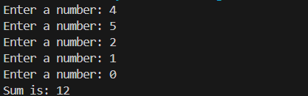

// Write a program to accept two integers x and n and compute x raised to n.

#include <iostream>
using namespace std;
int main() {
int x, n;
long long result = 1; // Use long long to handle large results
cout << "Enter base: ";
cin >> x;
cout << "Enter exponent: ";
cin >> n;

if (n < 0) {
cout << "negative exponent invalid!" << endl;
return 1;
}

for (int i = 0; i < n; i++) {
result *= x;
}

cout << x << "^" << n << " is: " << result << endl;
return 0;
}

Output:
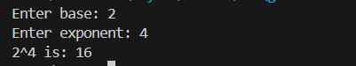

// Write a program to find factorial of a given number. ex:no5 fact=5*4*3*2*1=120

#include<iostream>
using namespace std;

int main(){
int n, f=1, i;
cout<<"Enter a number: ";
cin>>n;
for(i=1;i<=n;i++){
f = f * i;
}
cout<<"Factorial of "<<n<<" is "<<f;
}

Output:
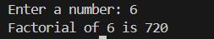

// Write a program to find m to the power n. m=3 and n=4 so 3*3*3*3

#include<iostream>
using namespace std;

int main(){
int n, m, p=1, i;
cout<<"enter base: ";
cin>>m;
cout<<"enter power: ";
cin>>n;
for(i=0;i<n;i++){
p *= m;
}
cout<<m<<" to the power "<<n<<" is "<<p;
}

Output:
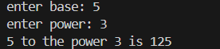

// Check if number is a prime number or not.:

#include<iostream>
using namespace std;

int main(){
int num,i;
cout<<"enter a number : ";
cin>>num;
if(num<=1){
cout<<"not prime";
}
for(int i=2;i<=num/2;i++){
if(num % i == 0){
cout<<"not prime";
break;
}else{
cout<<"prime";
break;
}
}
}

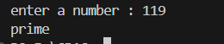

// Sum of series :
// 1+2+3+….+n

#include<iostream>
using namespace std;

int main(){
int n,i;
int sum=0;
cout<<"Enter number: ";
cin>>n;
for(i=1;i<=n;i++){
sum = sum + i;
}
cout<<"sum = "<<sum;
}

Output:
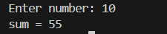

// Check whether the number is palindrome or not?

#include<iostream>
using namespace std;

int main(){
int num, i, rev, digit;
cout<<"Enter a number";
cin>>num;
int temp = num;
while(temp != 0){
digit = temp % 10;
rev = rev * 10 + digit;
temp = temp / 10;
}
if(rev == num){
cout<<"palindrome";
}else{
cout<<"not palindrome";
}
}

Output:
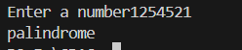

// Write a program to find sum of all even and odd numbers between 1 to n.

#include<iostream>
using namespace std;

int main(){
int n, i, evenSum = 0, oddSum = 0;
cout << "Enter number: ";
cin >> n;

for(i = 1; i <= n; i++){
if(i % 2 == 0){
evenSum += i;
} else {
oddSum += i;
}
}

cout << "Sum of even numbers = " << evenSum << endl;
cout << "Sum of odd numbers = " << oddSum << endl;

return 0;
}

Output:
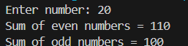

// Write a program to enter a number and print its reverse.

#include<iostream>
using namespace std;

int main(){
int num, i, rev = 0, digit;
cout << "Enter a number: ";
cin >> num;
int temp = num;

while(temp != 0){
digit = temp % 10;
rev = rev * 10 + digit;
temp = temp / 10;
}

cout << "Reversed number: " << rev << endl;

return 0;
}

Output:


// Write a program to print all Prime numbers between 1 to n.

#include<iostream>
using namespace std;

int main(){
int n, i, j, isPrime;
cout << "Enter number: ";
cin >> n;

cout << "Prime numbers between 1 and " << n << " are: "<< endl;
for(i = 2; i <= n; i++){
isPrime = 1;
for(j = 2; j <= i / 2; j++){
if(i % j == 0){
isPrime = 0;
break;
}
}
if(isPrime){
cout << i << " ";
}
}

cout << endl;
return 0;
}

Output:
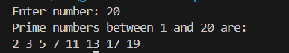
// Write a program to check entered number is Armstrong number or not.

#include<iostream>
using namespace std;

int main() {
int num, orig, remainder, result = 0, n = 0;
cout << "Enter an integer: ";
cin >> num;

orig = num;

while (orig != 0) {
remainder = orig % 10;
result += remainder * remainder * remainder;
orig /= 10;
}

if (result == num) {
cout << num << " is an Armstrong number." << endl;
} else {
cout << num << " is not an Armstrong number." << endl;
}

return 0;
}

Output:
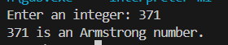

// Write a program to find greatest of three numbers using nested if-else.

#include<iostream>
using namespace std;

int main(){
int a,b,c;
cout << "Enter three numbers: ";
cin >> a >> b >> c;
if(a >= b){
if(a >= c){
cout << a <<" is greater"<< endl;
} else {
cout << c <<" is greater"<< endl;
}
} else {
if(b >= c){
cout << b <<" is greater"<< endl;
} else {
cout << c <<" is greater"<< endl;
}
}
}

Output:
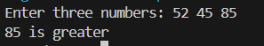

// Accept a single digit from the user and display it in words. For example, if digit entered is 9, display Nine.

#include<iostream>
using namespace std;

int main() {
int digit;
cout << "Enter a single digit (0-9): ";
cin >> digit;

switch(digit) {
case 0:
cout << "Zero" << endl;
break;
case 1:
cout << "One" << endl;
break;
case 2:
cout << "Two" << endl;
break;
case 3:
cout << "Three" << endl;
break;
case 4:
cout << "Four" << endl;
break;
case 5:
cout << "Five" << endl;
break;
case 6:
cout << "Six" << endl;
break;
case 7:
cout << "Seven" << endl;
break;
case 8:
cout << "Eight" << endl;
break;
case 9:
cout << "Nine" << endl;
break;
default:
cout << "Invalid input" << endl;
break;
}

return 0;
}

Output:
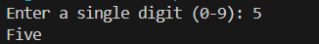

// Write a program, which accepts two integers and an operator as a character (+ - * / ), performs the
// corresponding operation and displays the result.

#include<iostream>
using namespace std;
int main(){
int a, b;
char ch;
cout << "Enter two integers: ";
cin >> a >> b;
cout << "Enter an operator (+, -, *, /): ";
cin >> ch;
switch(ch){
case '+':
cout << "Result: " << a + b << endl;
break;
case '-':
cout << "Result: " << a - b << endl;
break;
case '*':
cout << "Result: " << a * b << endl;
break;
case '/':
if(b != 0){
cout << "Result: " << a / b << endl;
} else {
cout << "Error: Division by zero" << endl;
}
break;
default:
cout << "Invalid operator" << endl;
break;
}
}

Output:
